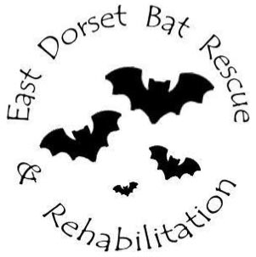

e-mail :- edbrr.bats@gmail.com

**Volunteer Application Form**

Name …………………………………………………………………………………………………………….…

Address……………………………………………………………………………………………………….…….

Contact numbers…………………………………. .... ……………………………………………………….….

Email…………………………………………………………………………………………………….

*Member of Dorset Bat Group and/or Bat Conservation Trust? ................................................

Confirm age over 18 years old - Yes / No

In case of emergency contact (name & number) ………………………………............................................

**Preferred Activities**

Bat care daytime ☐ evenings ☐

Bat rescue / collection daytime ☐ evenings ☐

weekends ☐

Distance prepared to travel. .............................................................................................

Bat release evenings ☐

Flying evenings ☐

Events/Educational talks daytime ☐ evenings ☐

weekends ☐

By agreeing to help with EDBRR I understand that I will have to comply with the training

provided in line with BCT guidelines and achieve a level of competency in handling bats that

the EDBRR committee recognise as being appropriate and adequate for the role.

I accept that if I do not achieve the EDBRR required level of competency I cannot handle

bats with them.

Signed:............................................................... Date:...........................................................

(Please sign to say that you are interested in volunteering for EDBRR, and that you are happy for us

to keep your details on file. No personal details are shared with any other organisations.)

*For insurance cover, membership of either of these is necessary.